**Experiments Name:** Synchronous Sequential Circuits.

**Objective:**

* Gain a practical understanding of State Diagrams and State Tables.
* Understand the concept of designing Sequential Circuits using Flip-Flops.
* Design and implement a Synchronous Sequential Circuit given a State Diagram.

**Apparatus:**

* 1 x IC 74107 JK Flip-Flop
* 1 x IC 7408 2-input AND gates
* 1 x IC 7404 Hex inverters (NOT gates)
* 1 x IC 7432 2-input OR gates
* 1 x IC 7474 Dual D Flip-Flops
* Trainer Board.
* Wires.

**Theory:**

A synchronous sequential circuit is a digital circuit composed of flip-flops and combinational logic, where the outputs depend not only on the present inputs but also on the circuit's state. The flip-flops serve as memory elements to store information.

In a synchronous sequential circuit, a clock signal synchronizes the operations. On each clock edge, the inputs are sampled, and the outputs are updated based on the current state and the combinational logic. The state transition is governed by a set of logical equations that define the next state in terms of the current state and inputs.

The circuit's behavior can be described using a state diagram, which illustrates the various states and the transitions between them. The design process involves determining the required states, defining the state transition table, and deriving the logic equations for each flip-flop and output.

Synchronous sequential circuits are widely used in digital systems, such as microprocessors, memory units, and communication protocols. They offer predictable and reliable operation, allowing for precise control and synchronization in complex digital systems.

To analyze and design Synchronous Sequential Circuits, we need to use State Tables and State Diagrams. The State Table (or Transition Table) shows how the state and output of the sequential circuit changes with respect to the current state and input. State Diagrams are simply graphical forms of the State Tables. In this type of diagram, a state is represented by a circle, and the (clock-triggered) transitions between states are indicated by directed lines connecting the circles. The binary number inside each circle identifies the state of the flip-flops. The directed lines are labeled with two binary numbers separated by a slash. The input value during the present state is labeled first, and the number after the slash gives the output during the present state with the given input.

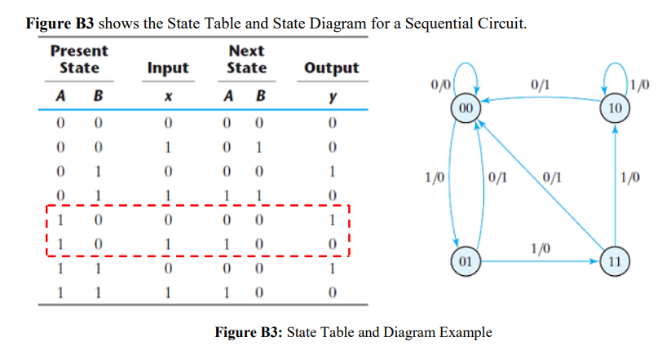

**Circuit Diagram:**

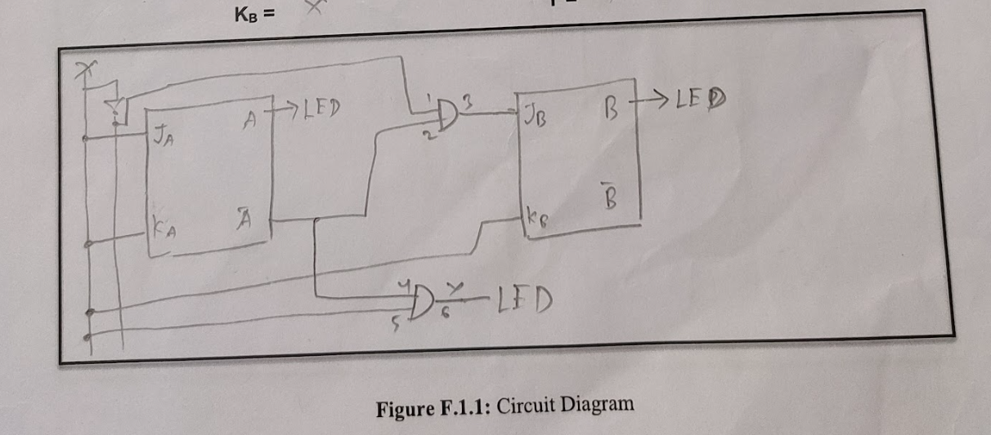

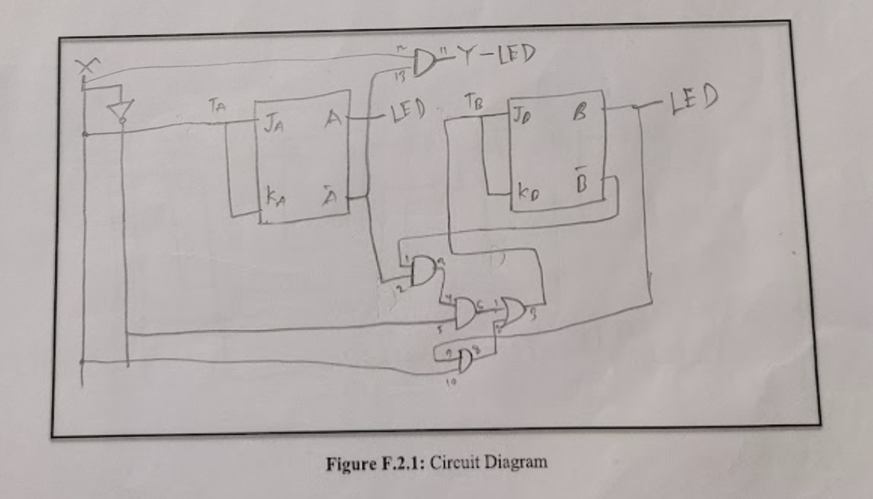

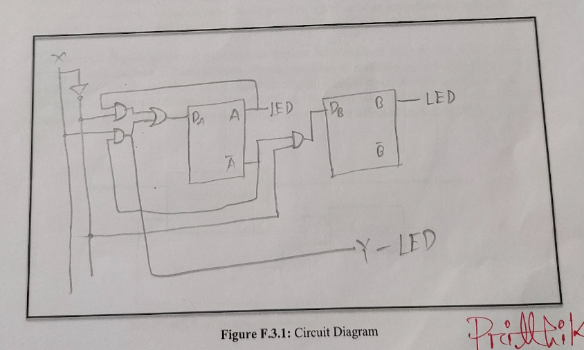

**Experimental Procedure:**

Experiment-1:

1. First, we construct the excitation Table for J-K Flip-Flop given bellow:

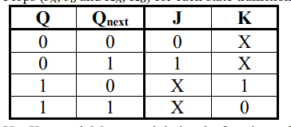

1. Using this excitation table, we complete the Experimental Data Table F.1.1.
2. After that, we use the K-Map to determine the input equation for the J-K Flip-Flop.
3. Then, we construct the circuit Diagram with some Pin details in Figure F.1.1.
4. After that we implement the circuit in the trainer board according to the pin diagram shown in Figure F.1.1.

Experiment-2:

1. First, we constructed the excitation table for T Flip-Flop given bellow:

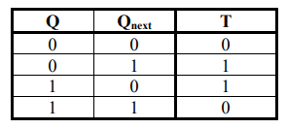

1. Using this excitation table, we complete the Experimental Data Table F.2.1.
2. Then, again we use the K-Map to determine the input equation for T Flip-Flops.
3. Then again draw a circuit diagram for T Flip-Flops.
4. After that, we simply follow the pin diagram already shown in the circuit diagram F.2.1 and implement the circuit diagram on the trainer board.

Experiment-3:

1. Like previous, again we constructed the excitation table for the D Flip-Flops given bellow:

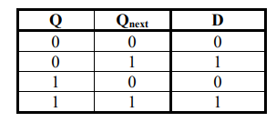

1. Then, we complete the experimental data table F.3.1,
2. Then complete the K-Map to determine the input for the D Flip-Flops.
3. After that, we again construct a circuit diagram shown in Figure F.3.1. And implement the circuit on the trainer board according to the pin diagram shown in the figure.

**Simulation:**

Attached.

**Experimental Data Table:**

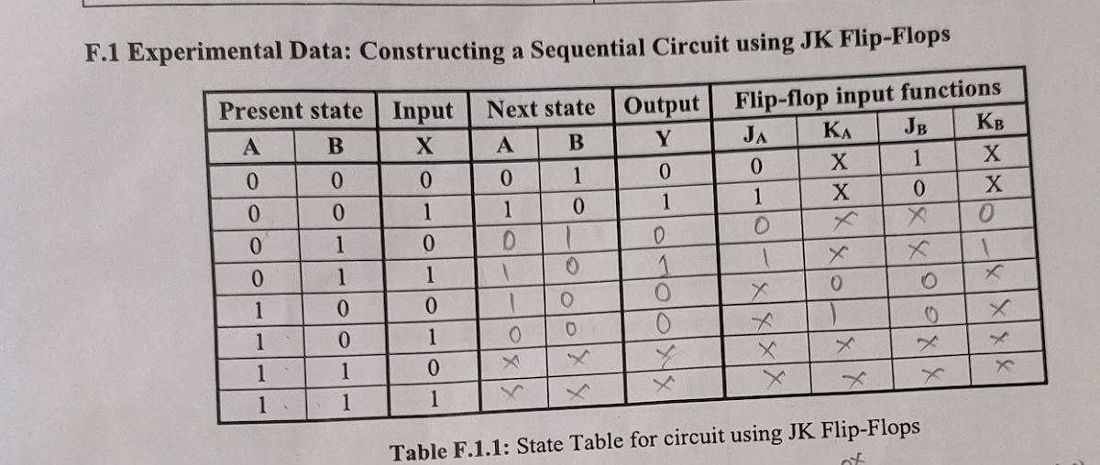

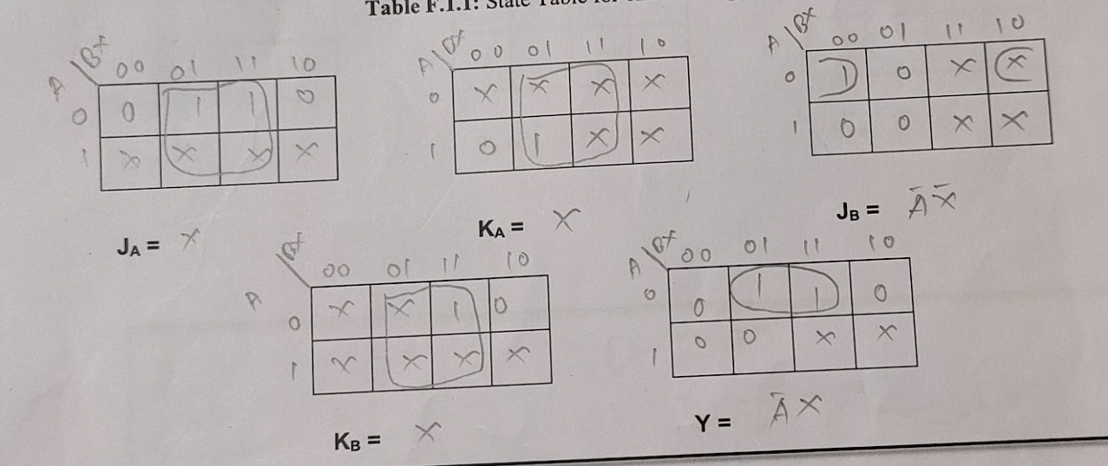

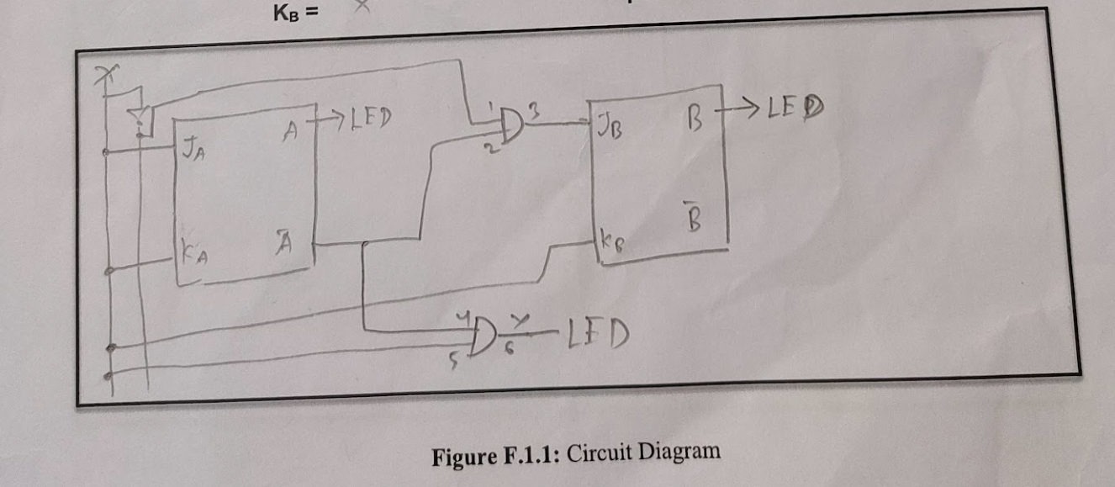

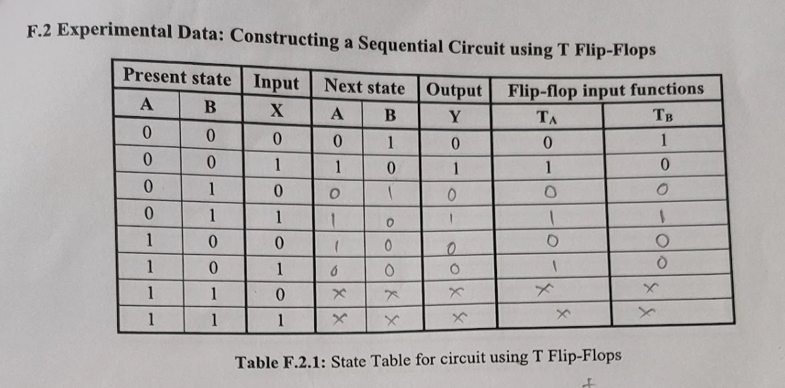

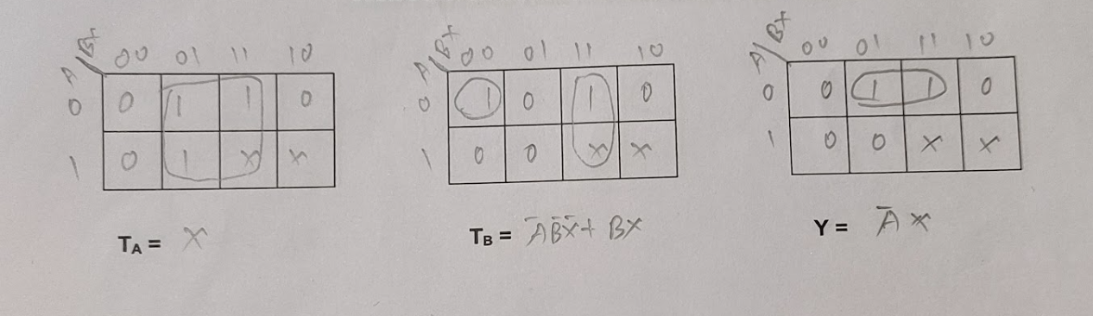

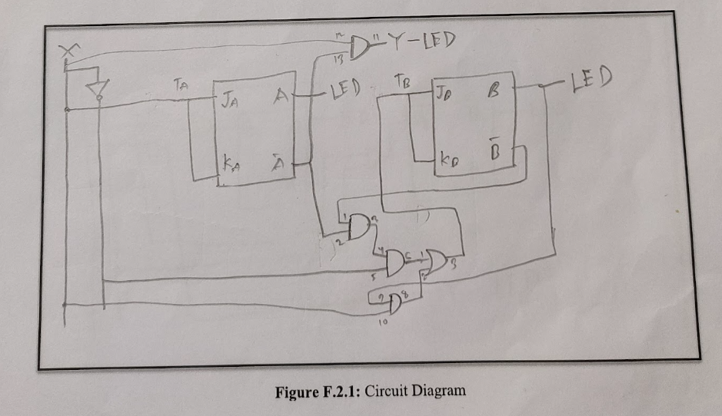

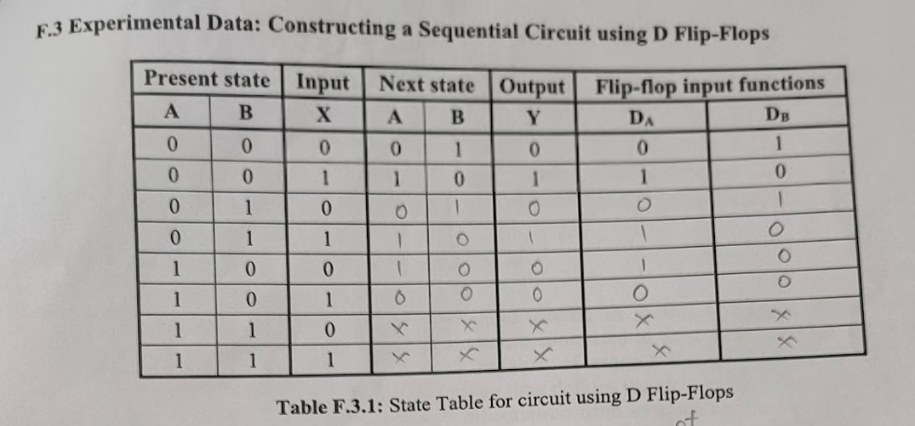

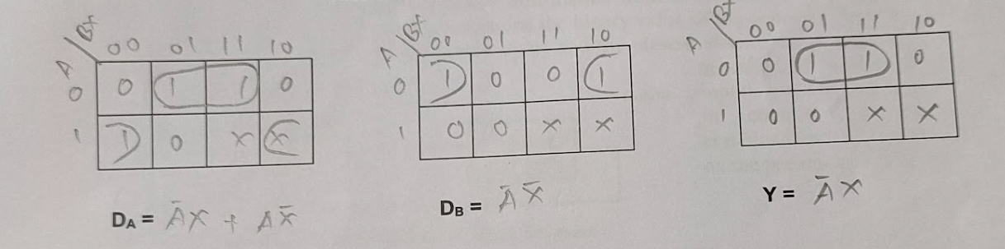

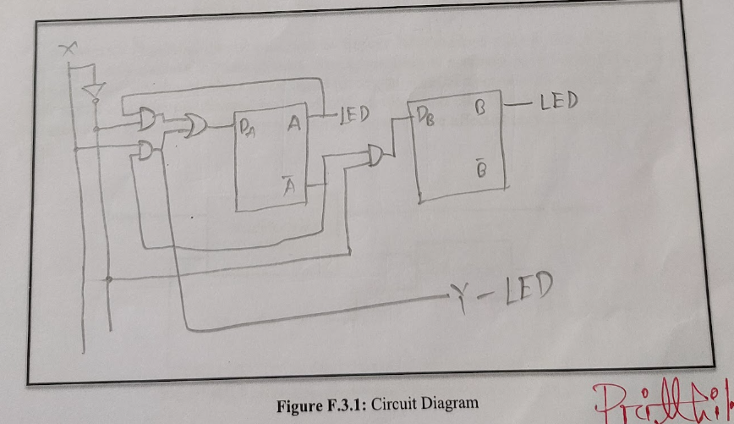

**Results:**

After completing the circuit, we test the circuit with our experimental data table. And the state of the circuit was changing according to the given sequence. Hence, we can say that we successfully implemented the circuit for a sequential State.

**Questions and Answers (Q/A):**

E.2:

Yes, Equation is the same as J-K Flip-Flop.

We know that in J-K Flip-Flop, if both inputs are same then the Flip-Flop works like a T Flip-Flop. Here, in the first experiment we gave the same input of X in 1st J-K Flip Flop. In the second experiment we also did the same. And in the experimental data table output of Y are same for both experiments. That’s why, output equation of Y is the same for both experiments.

E.3: Draw the IC diagram for the logic circuit in Figure F.3.1.

**Discussion:**

From this experiment, we learnt about the State Diagrams and State Tables. We also gain some practical understanding about that. In addition, we understand the concept of designing Sequential Circuits using Flip-Flops. We can now design and implement Synchronous Sequential Circuits for a given State Diagram. In this experiment we don’t face any problems. We successfully completed the experiment within the given time.